SKILL 6
Database Commands
- CREATE DATABASE – Creates a new database.
- USE – Selects the database.
- CREATE TABLE – Creates a table.
- INSERT INTO – Adds records to a table.
- SELECT – Displays/retrieves data.
- UPDATE – Modifies existing data.
- DELETE – Removes records.
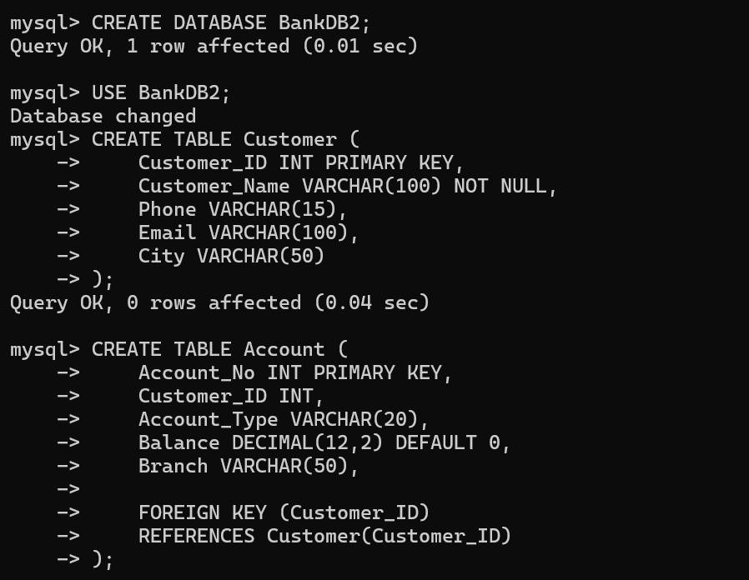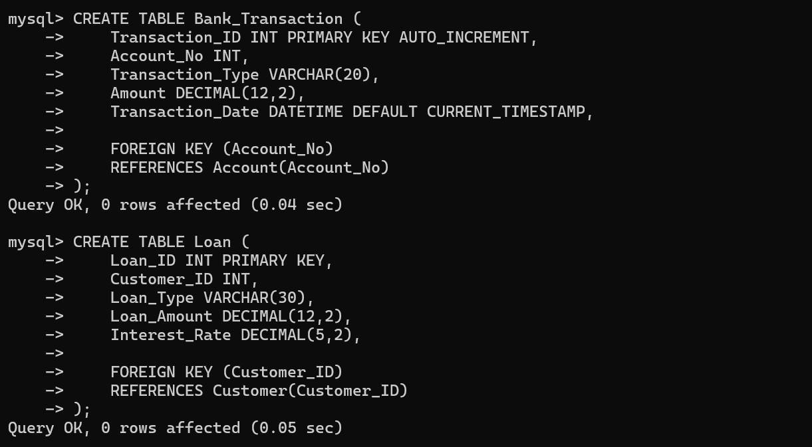

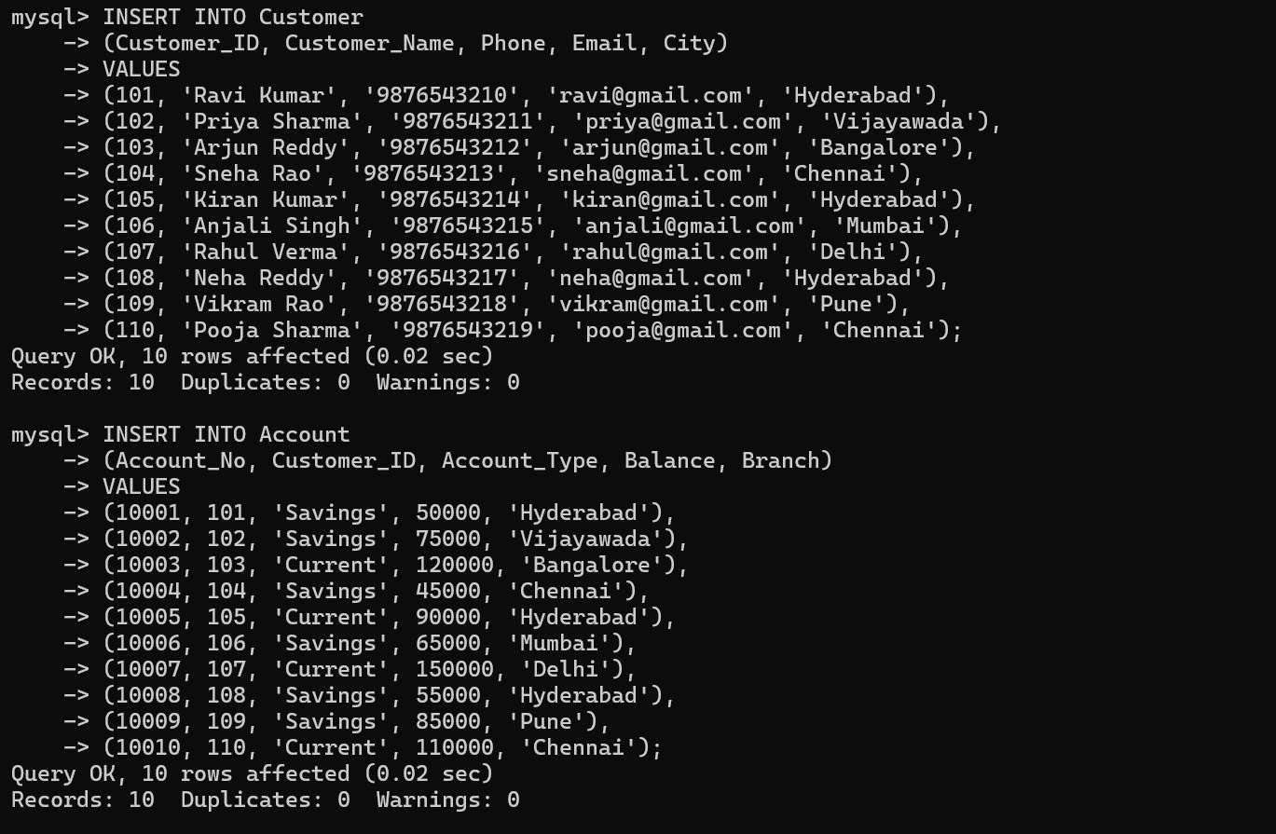

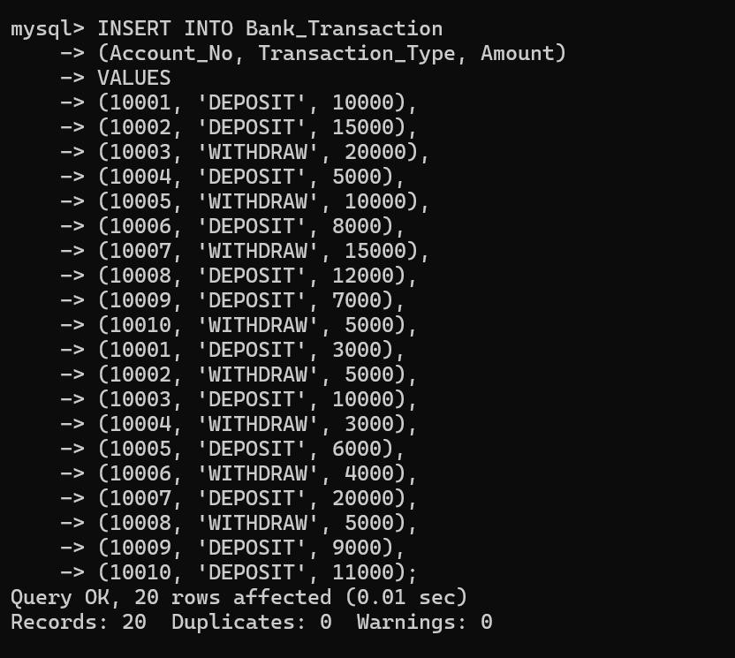

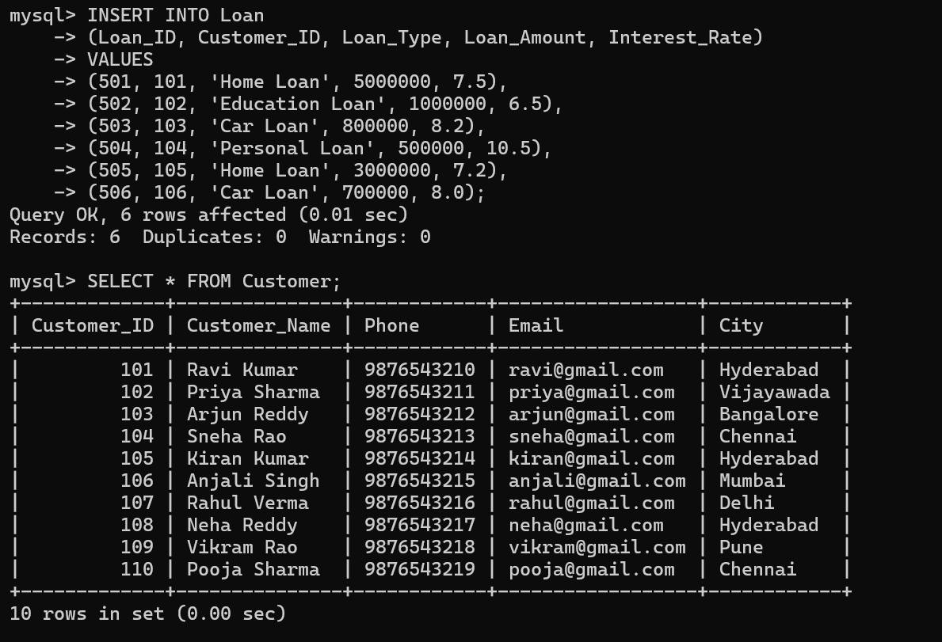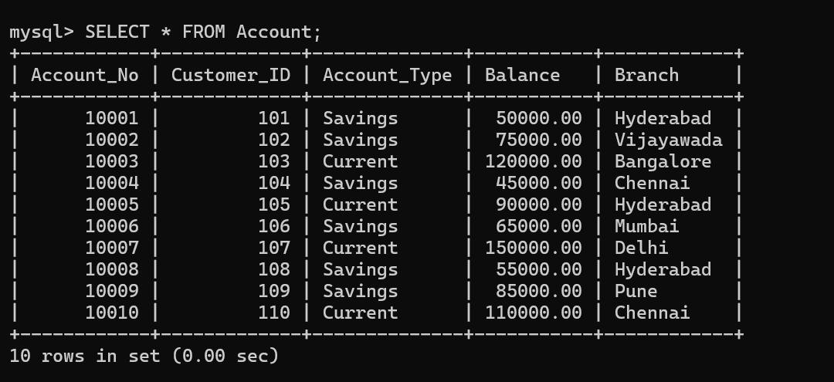

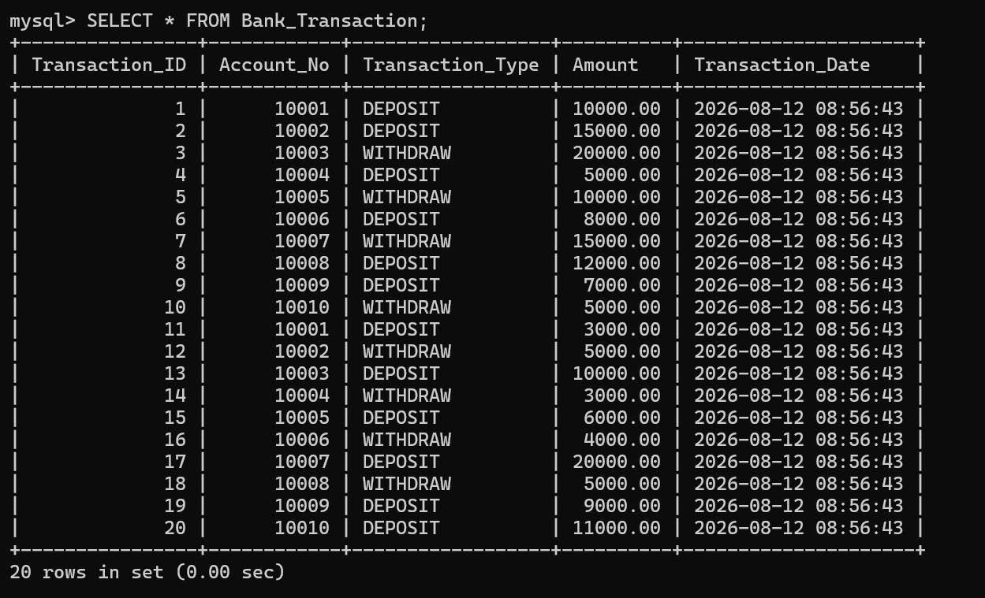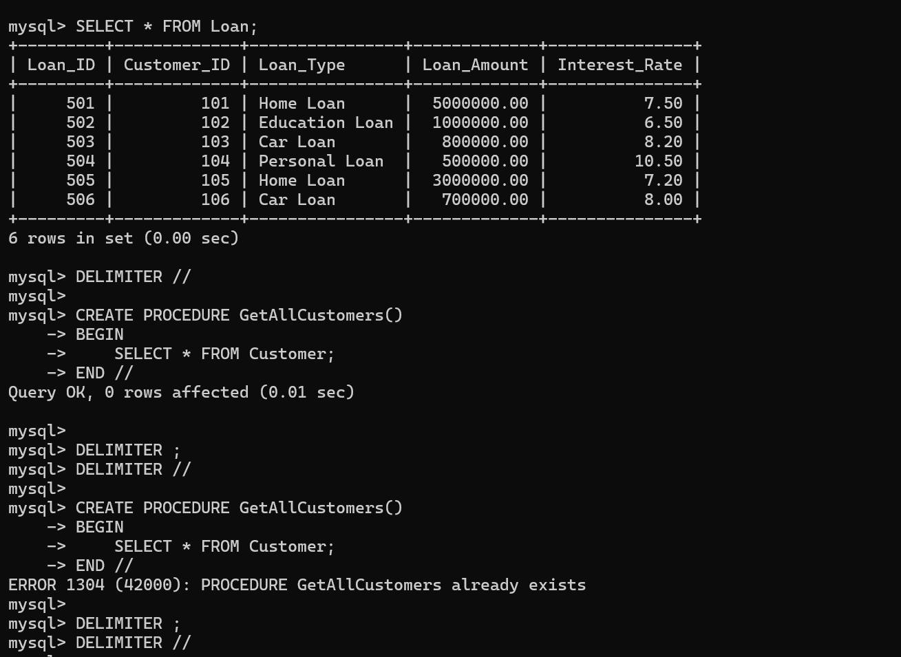

A stored procedure is a reusable set of SQL statements stored in the database.
- CREATE PROCEDURE – Creates a procedure.
- CALL – Executes a procedure.
- IN – Accepts input from the user.
- OUT – Returns a value from the procedure.
- 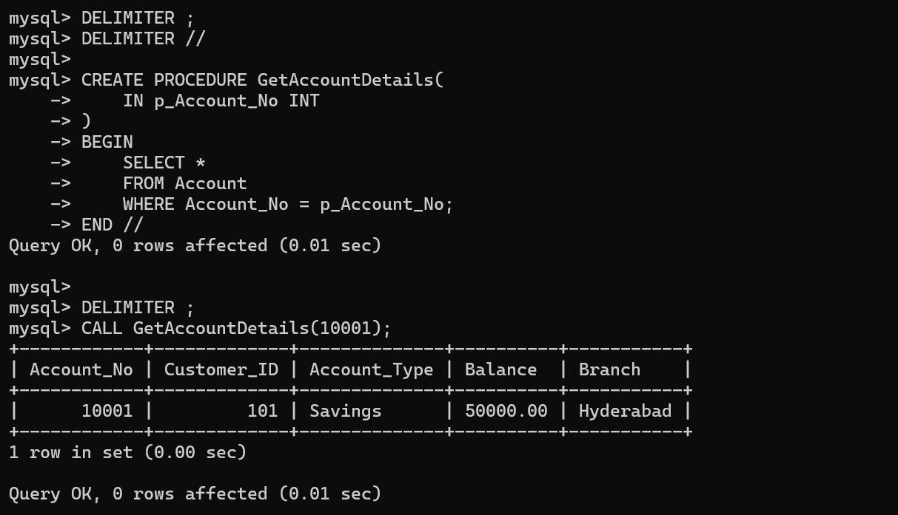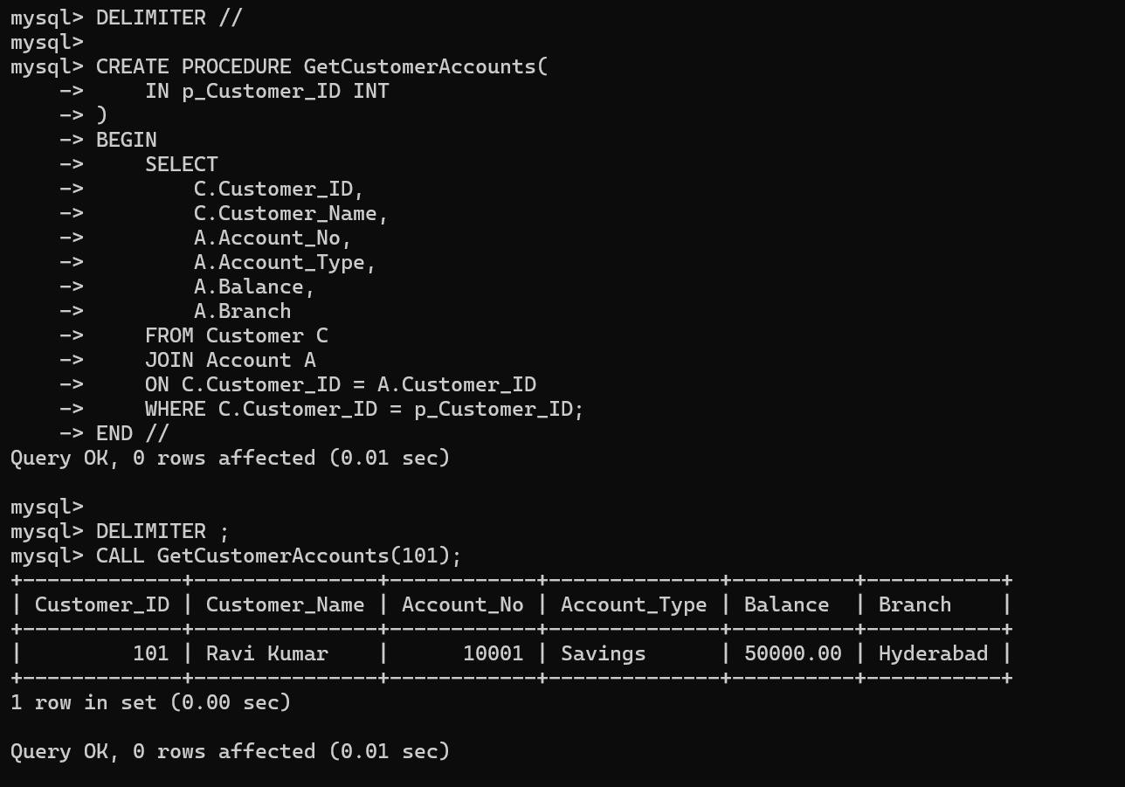DROP PROCEDURE – Deletes a procedure.

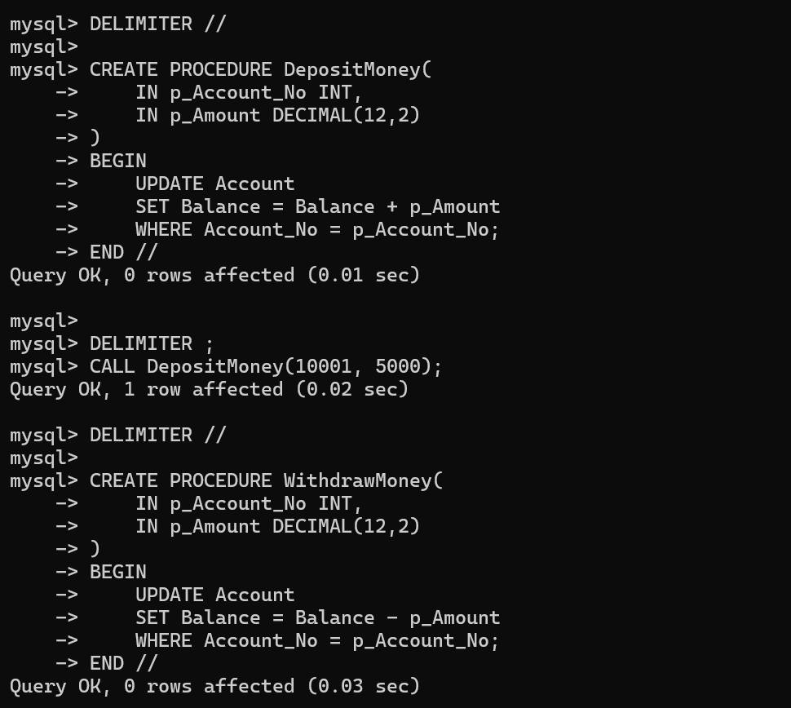

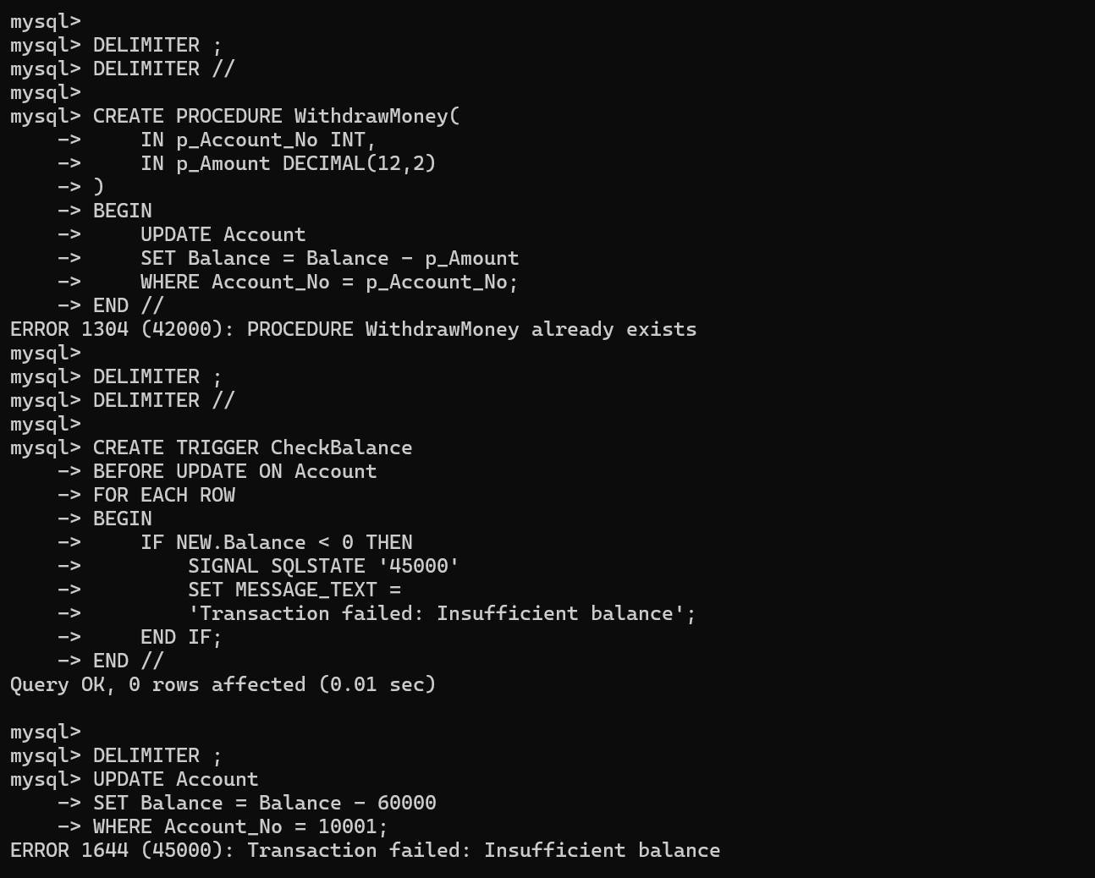

A trigger is automatically executed when a specified database event occurs.
- CREATE TRIGGER – Creates a trigger.
- BEFORE INSERT – Executes before inserting data.
- BEFORE UPDATE – Executes before updating data.
- AFTER INSERT – Executes after inserting data.
- DROP TRIGGER – Deletes a trigger.
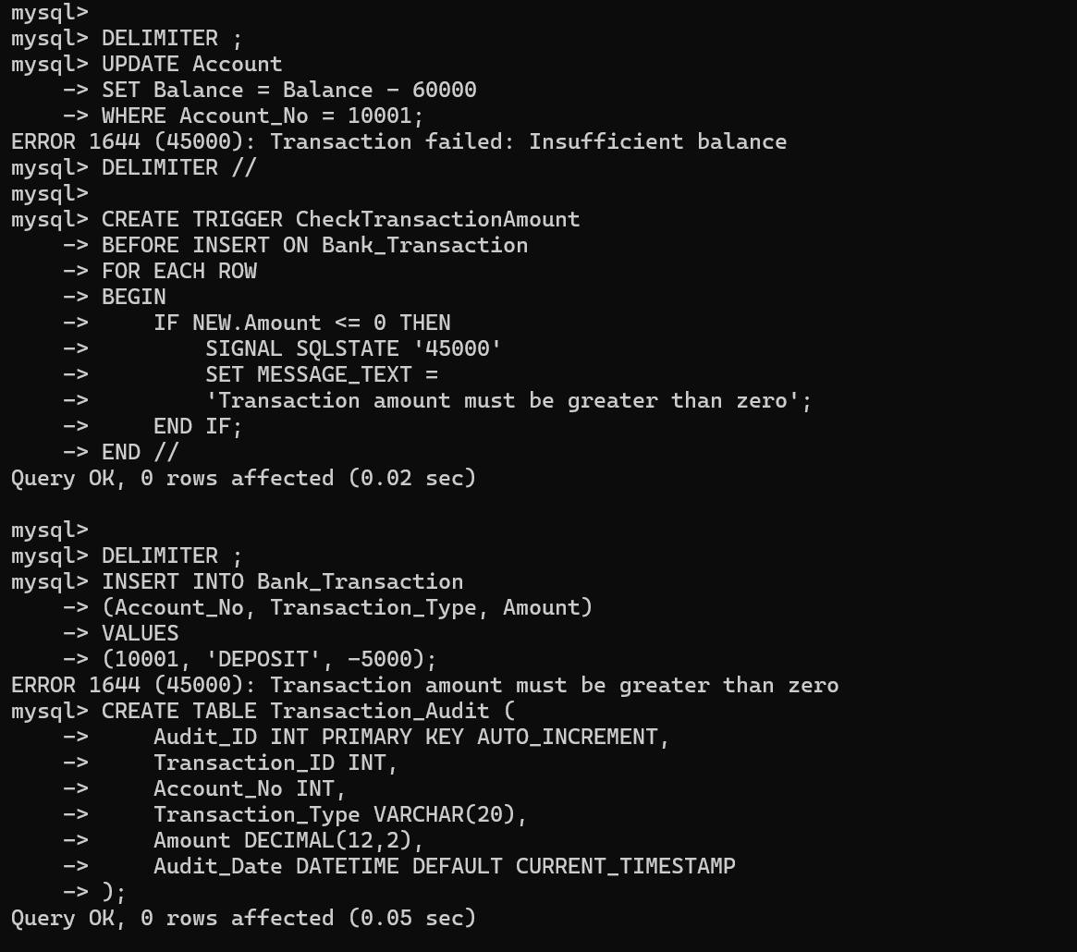
Uses: prevent negative balance, validate transaction amounts, maintain transaction audit, and automatically update account balance.

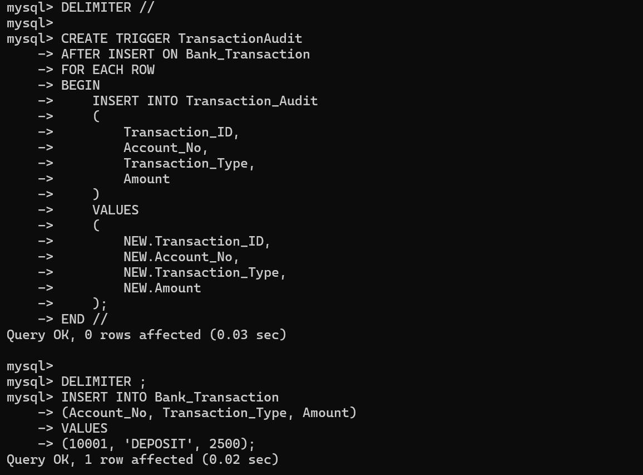

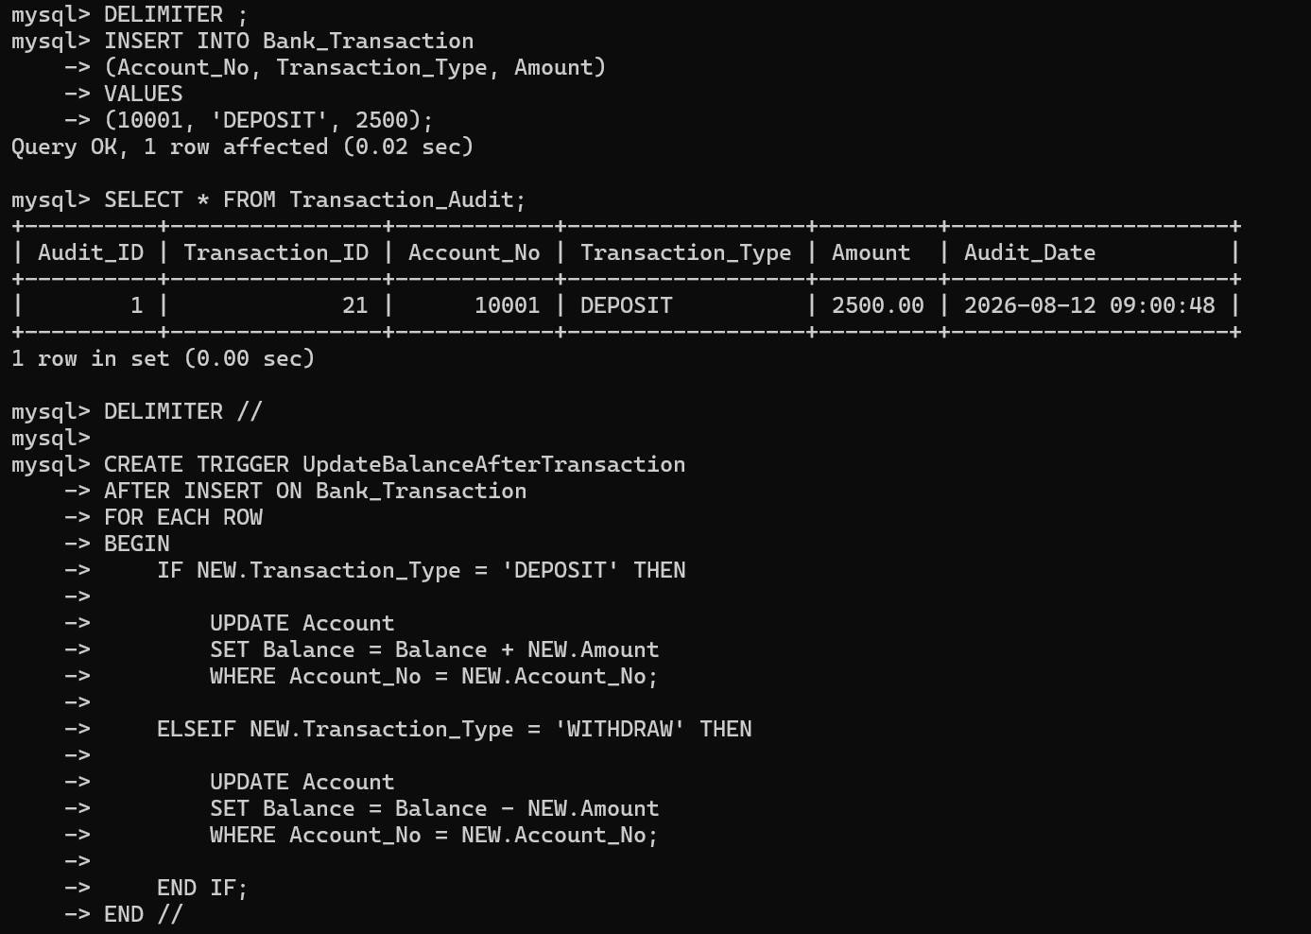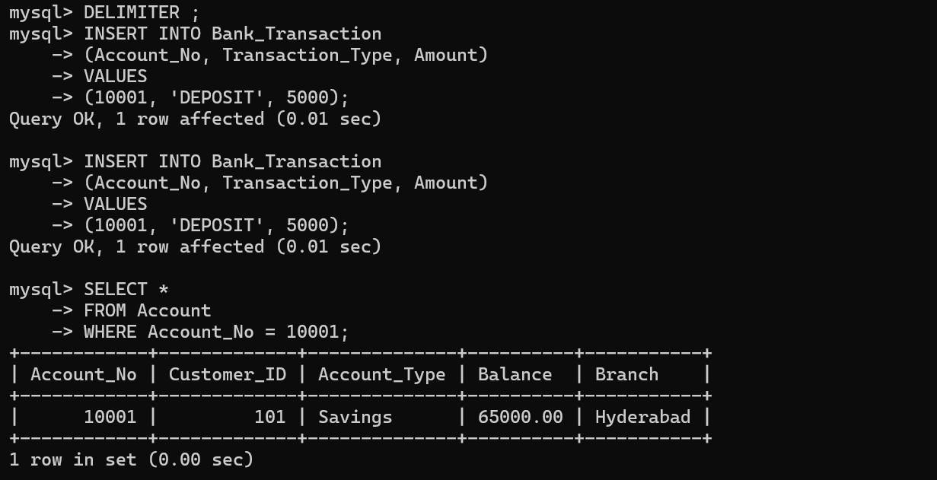

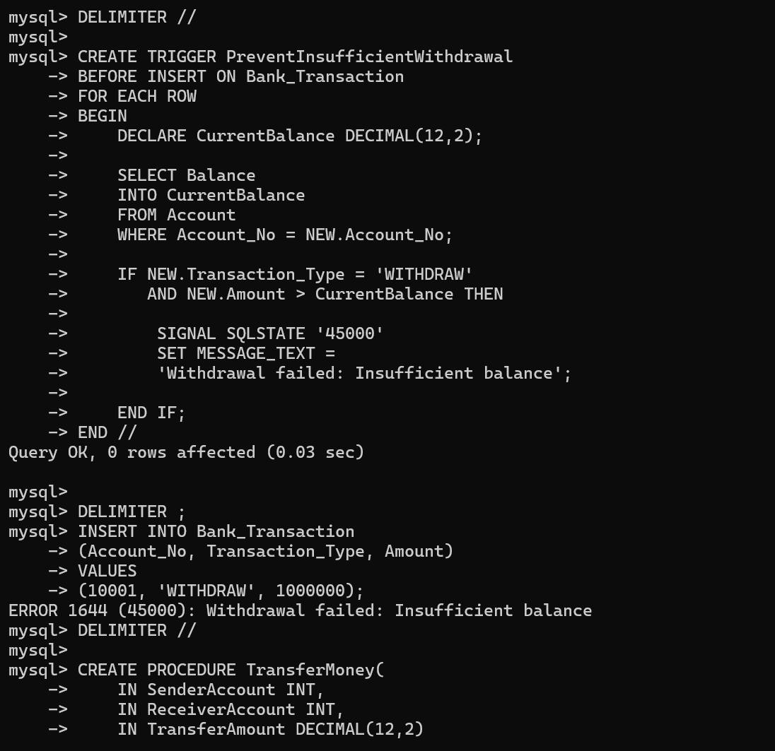

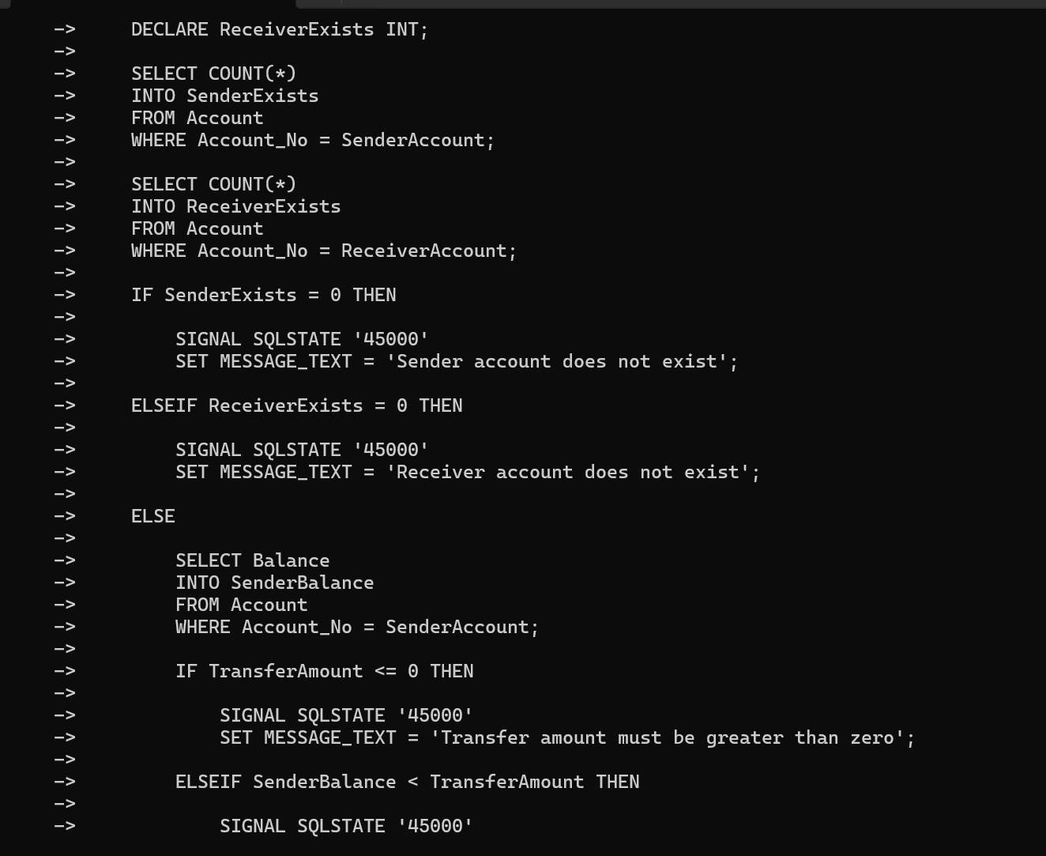

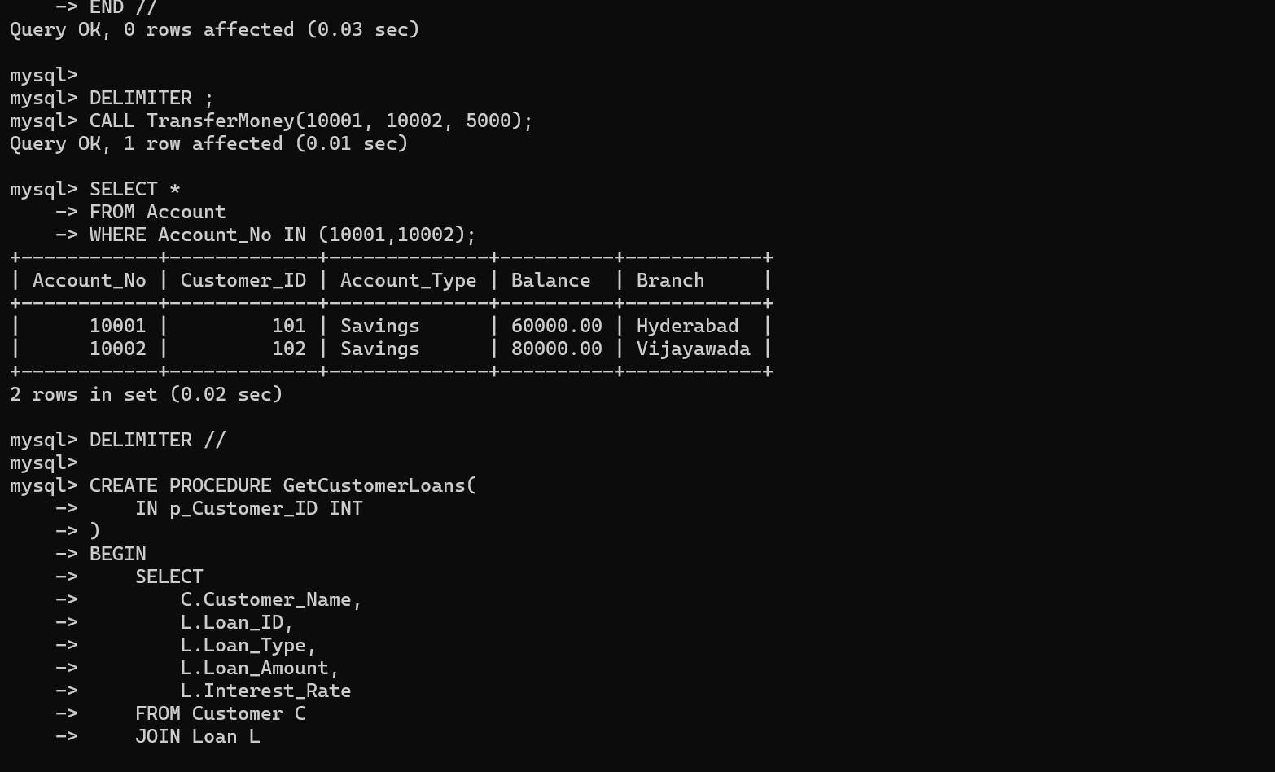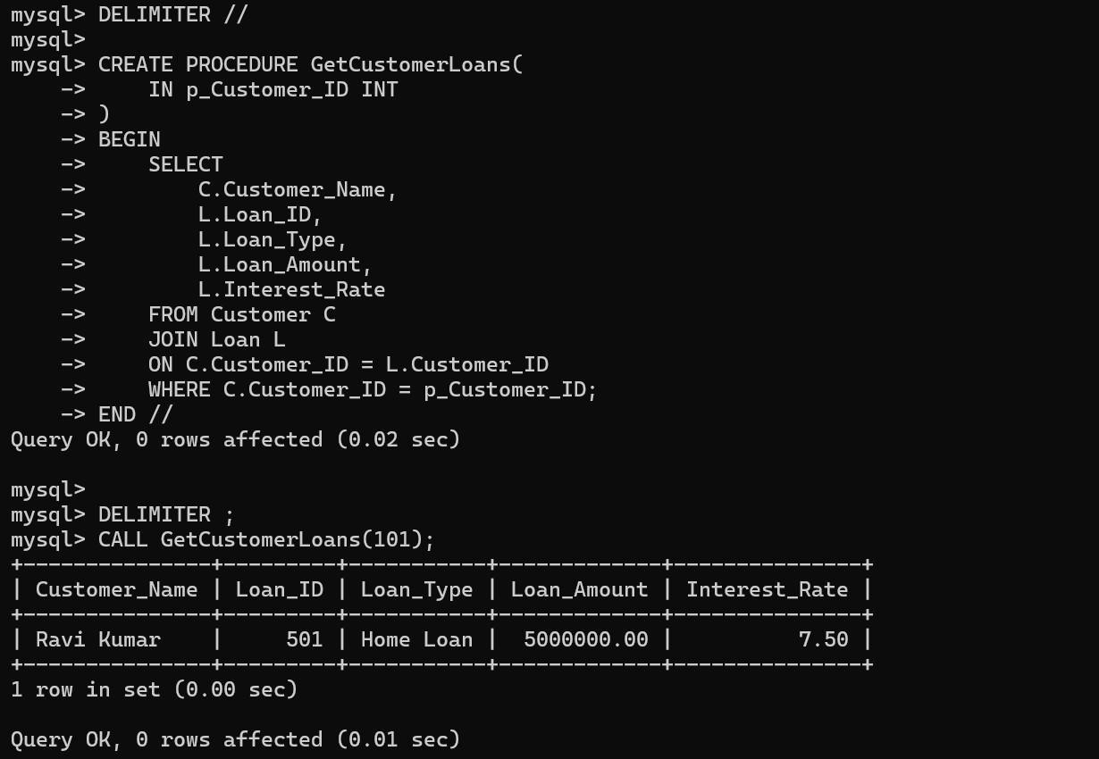

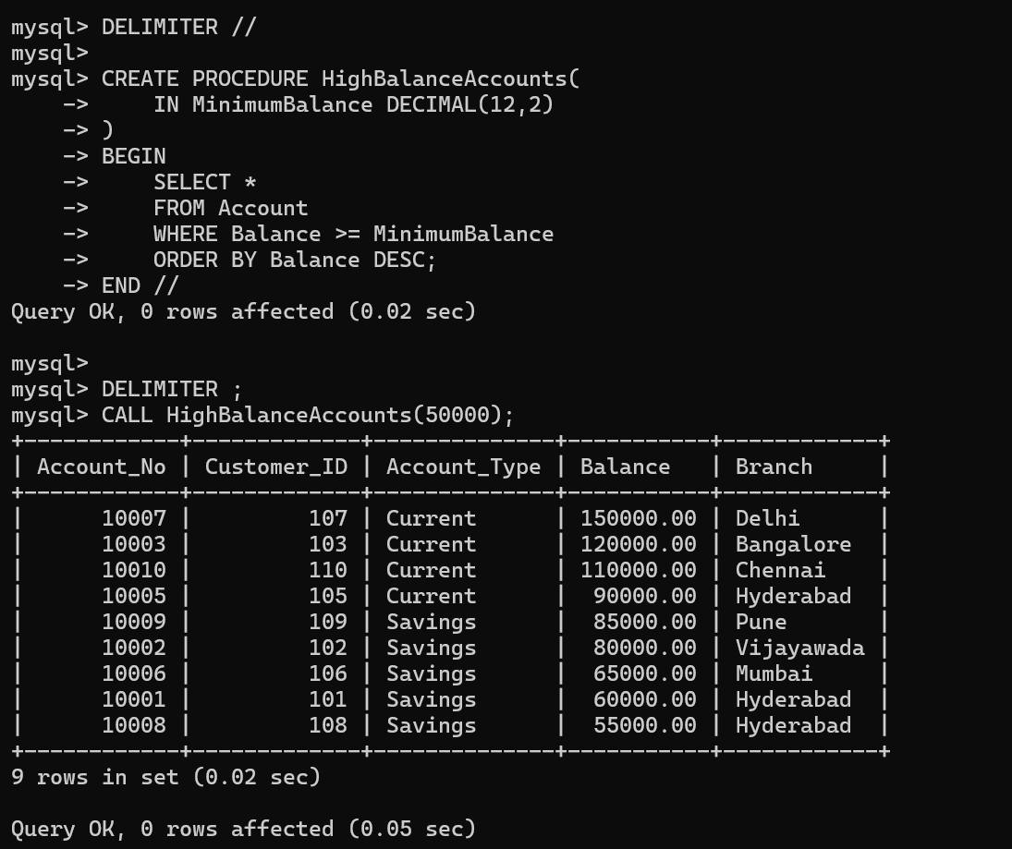

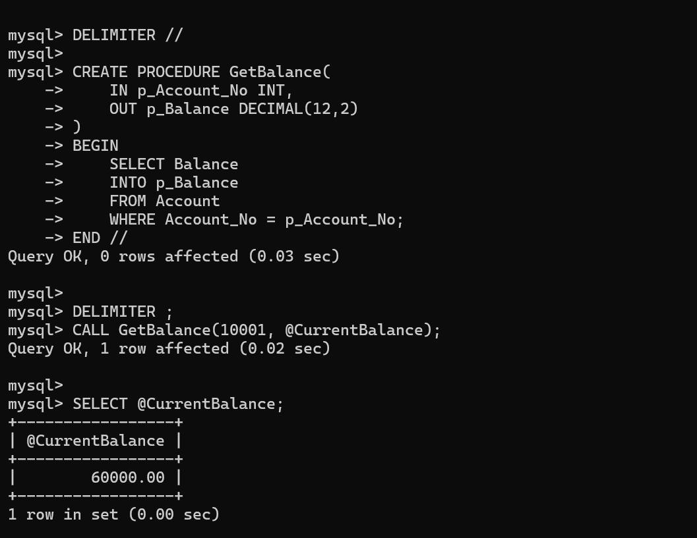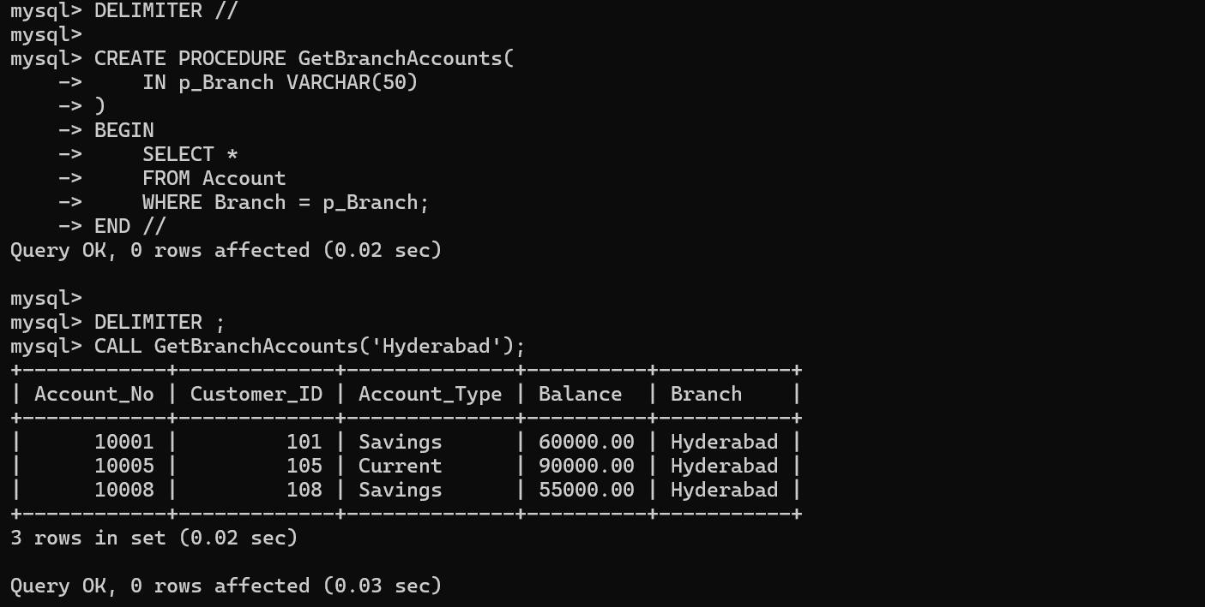

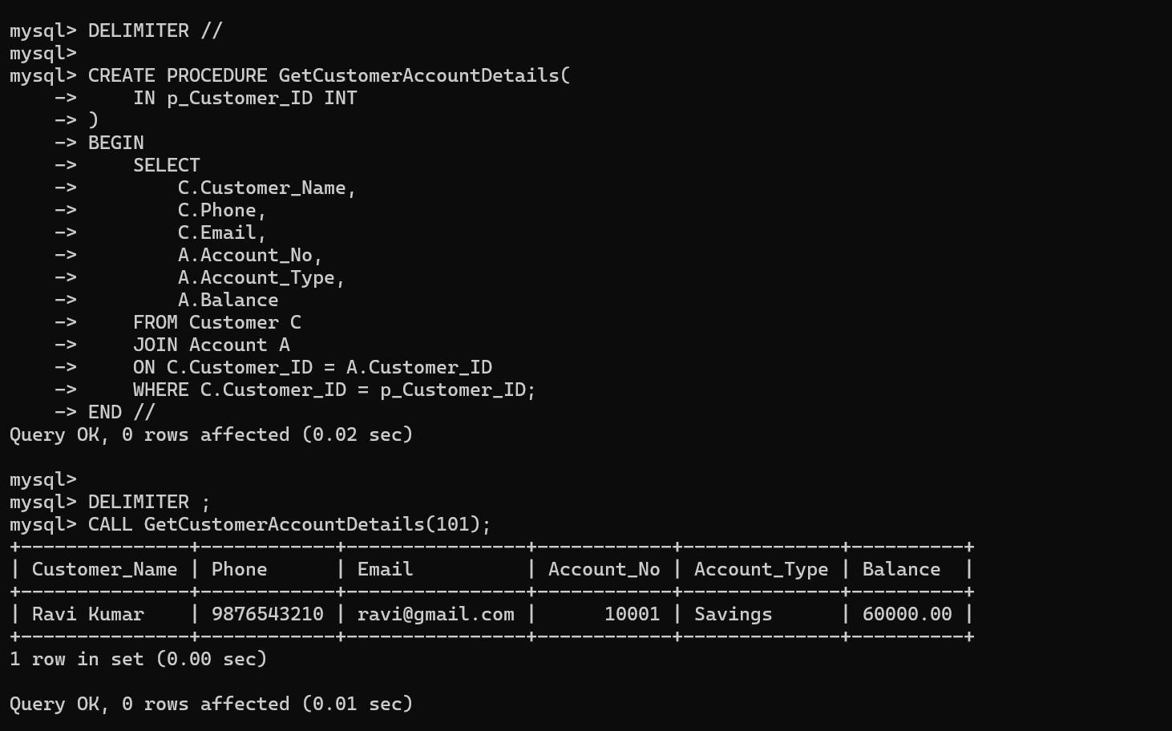

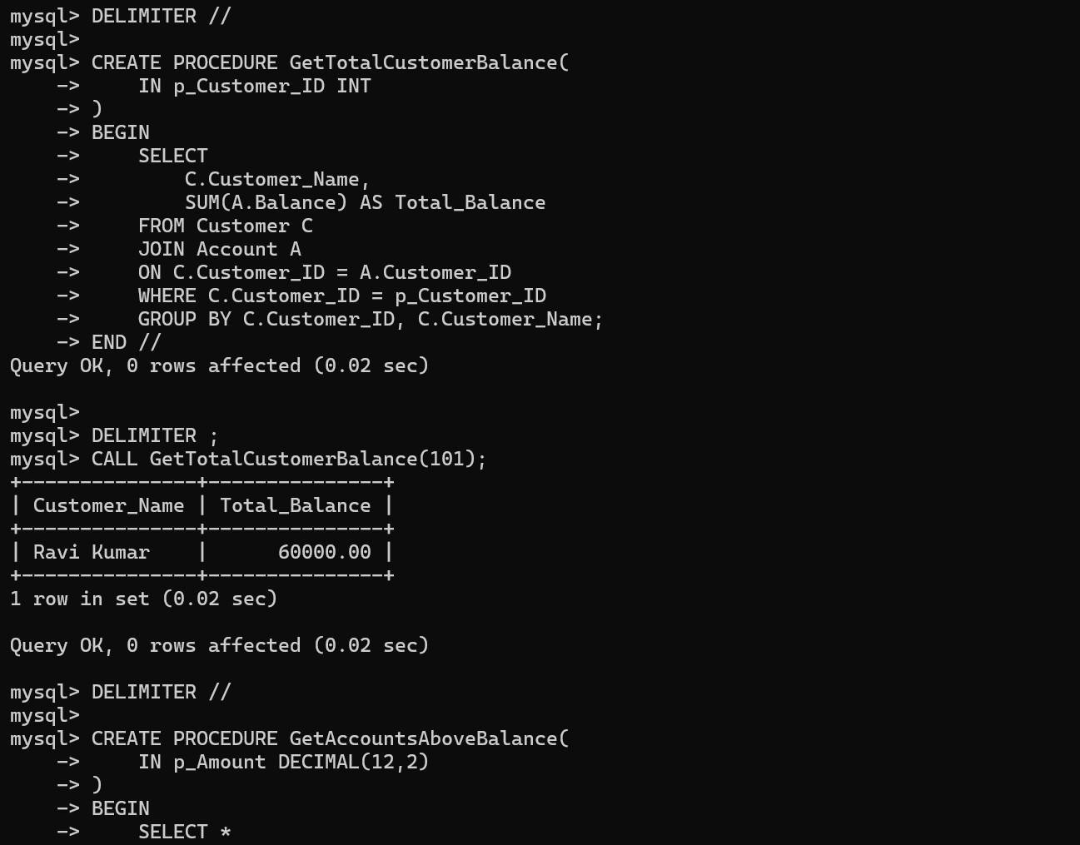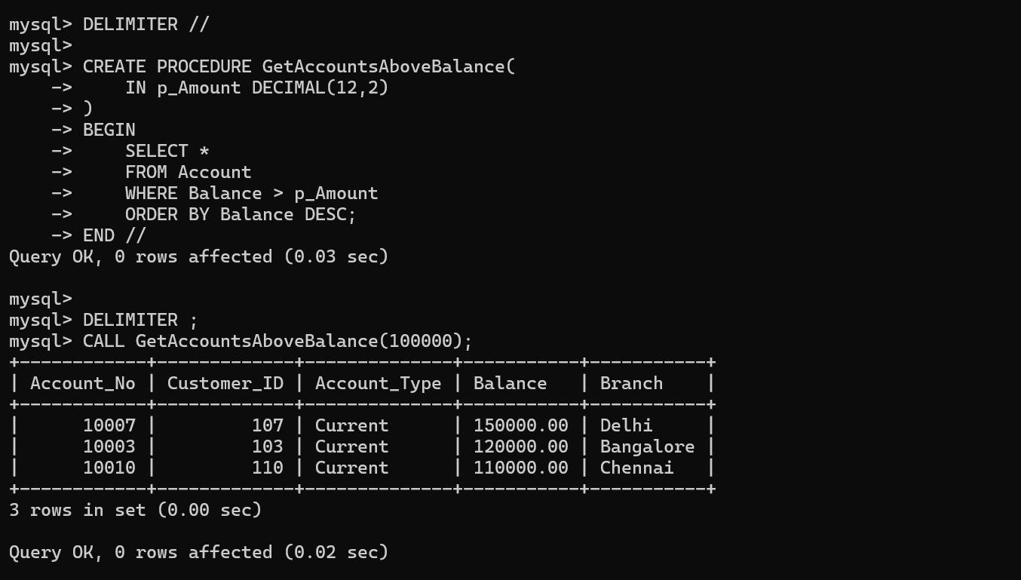

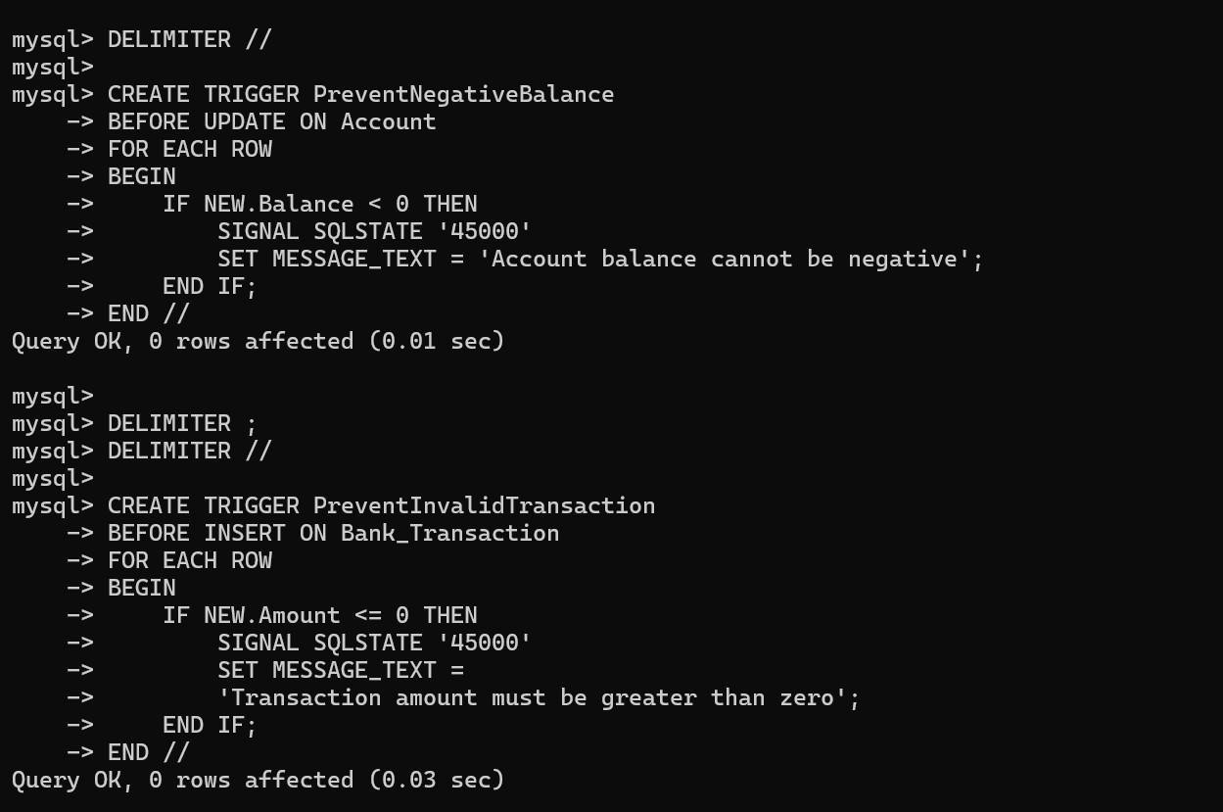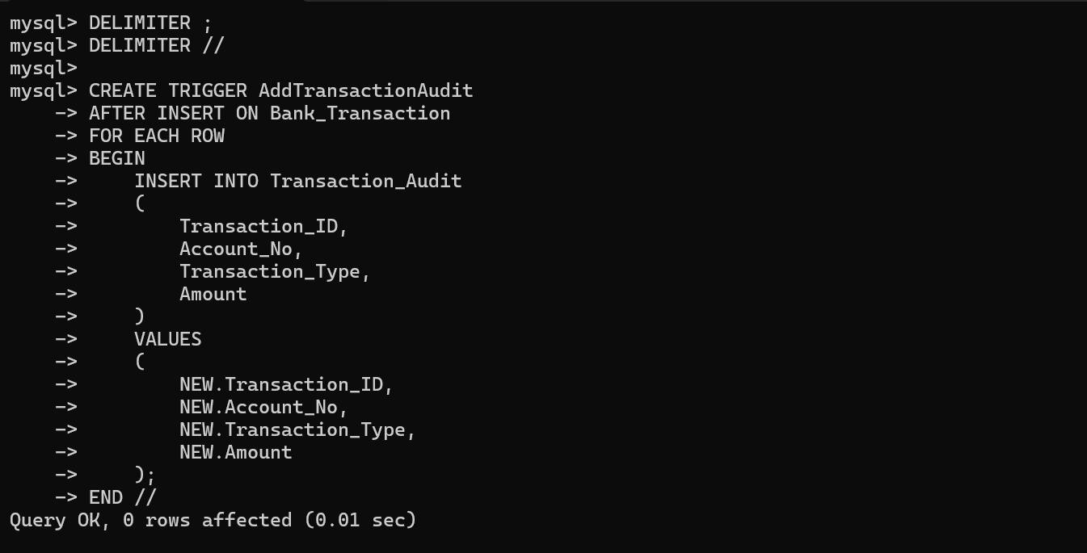

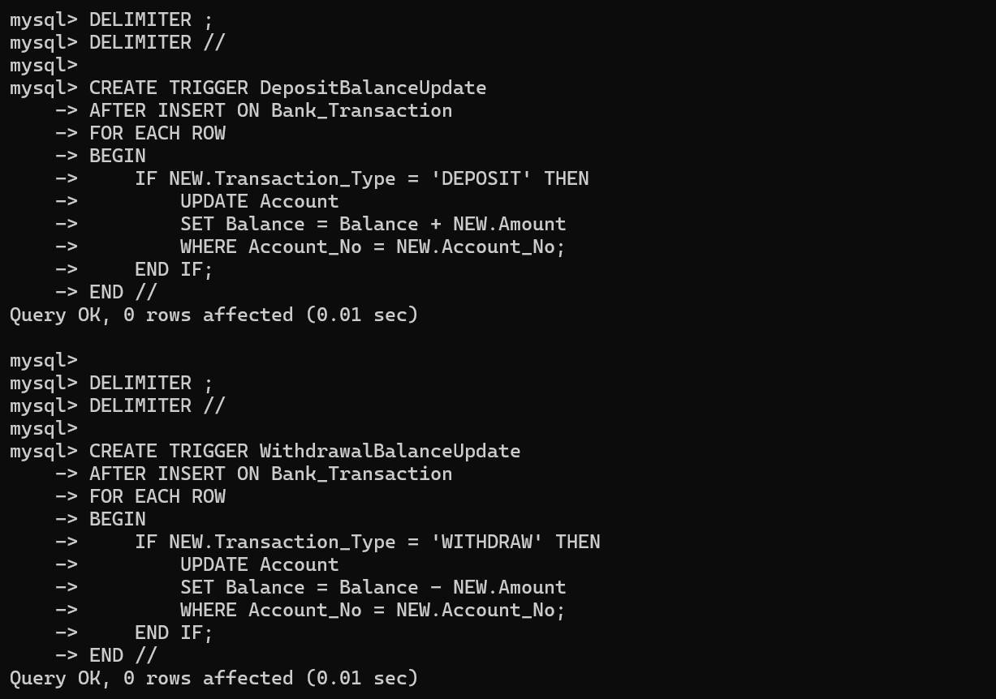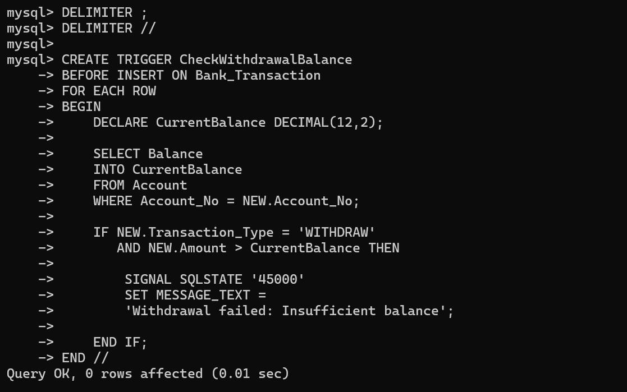

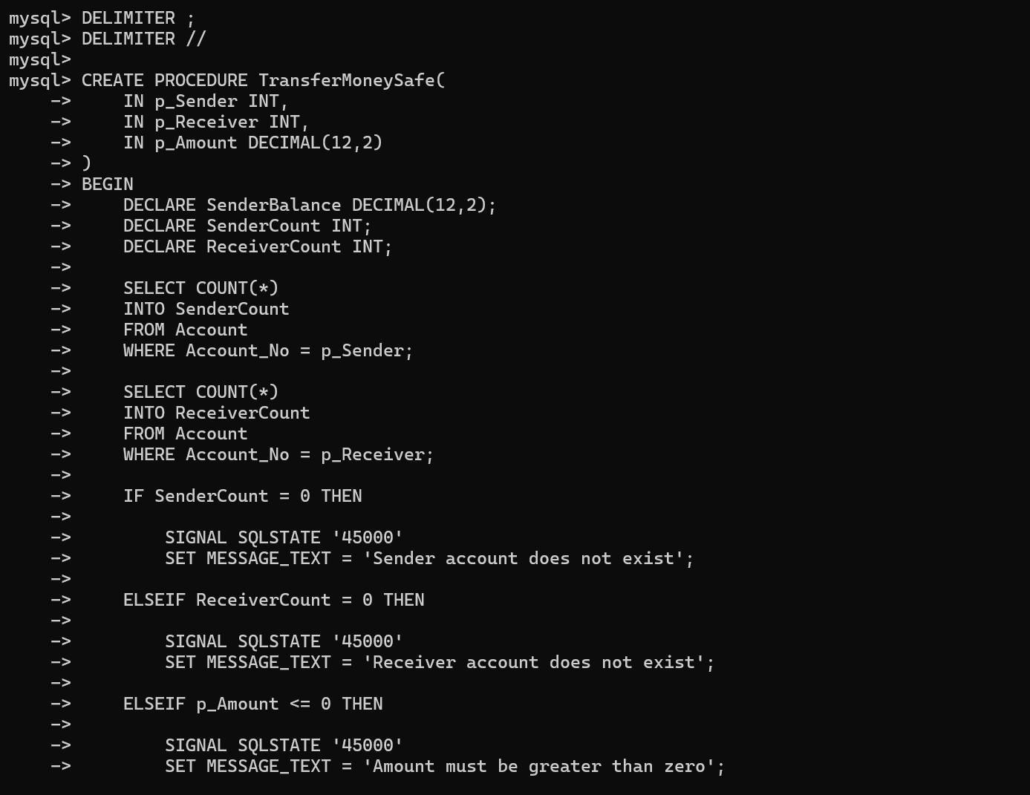

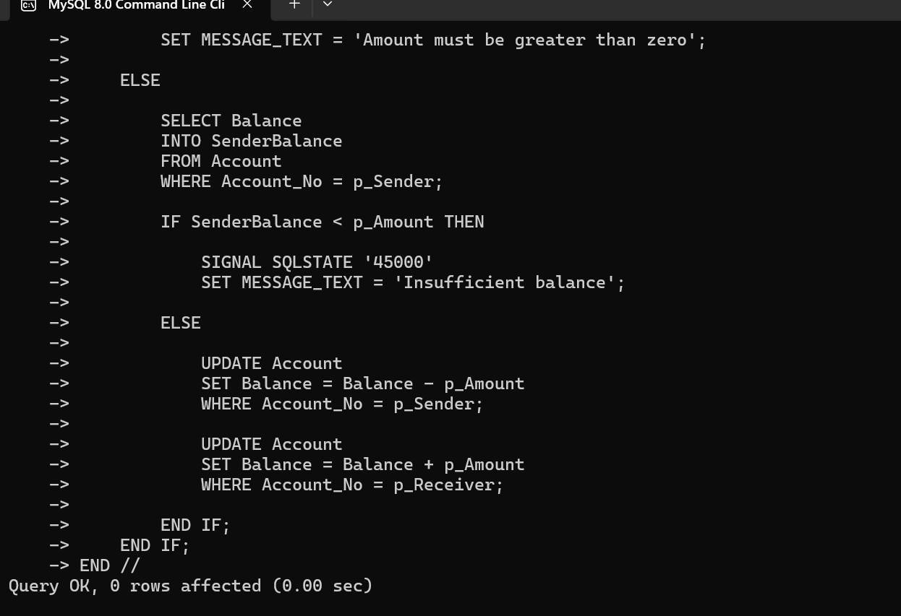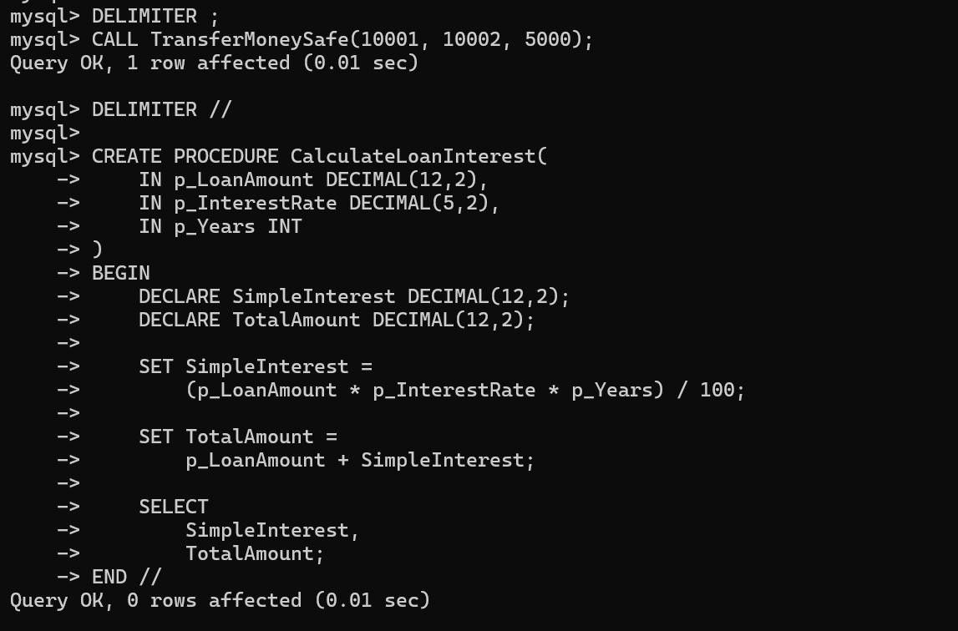

IF / ELSEIF / ELSE – Performs operations based on conditions.
DECLARE – Creates a local variable.
SELECT ... INTO – Stores a selected value in a variable.
SIGNAL SQLSTATE '45000' – Generates a custom error and stops an invalid operation.
DELIMITER – Allows procedures/triggers containing multiple SQL statements to be defined.

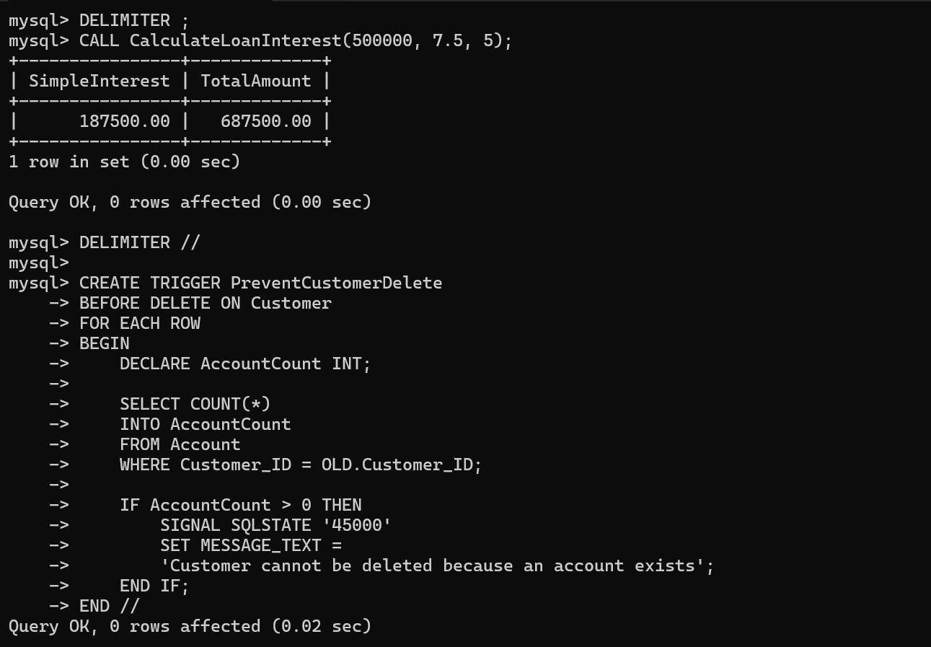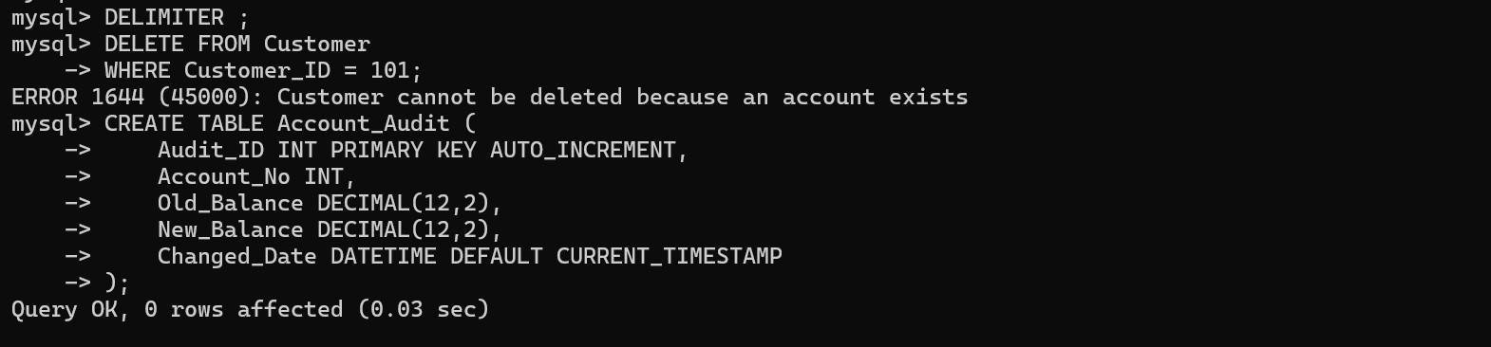

SHOW TRIGGERS – Displays available triggers.
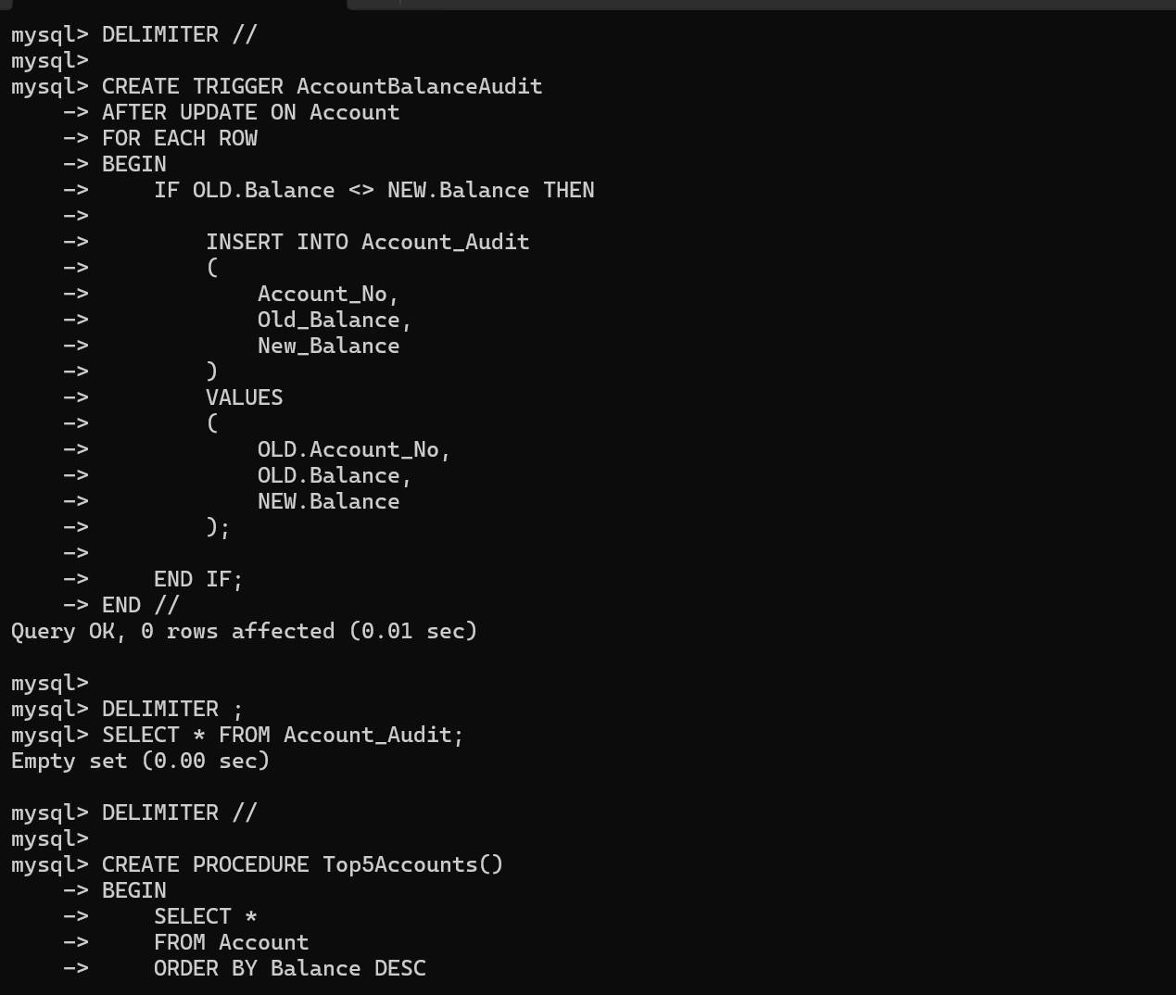
SHOW CREATE TRIGGER – Displays the code of a trigger. SHOW PROCEDURE STATUS – Displays stored procedures. DROP TRIGGER / DROP PROCEDURE – Removes them.

